INSTITUTO POLITECNICO NACIONAL

Escuela Superior de Cómputo

Unit of learning

“Analogic electronics”

Practice 8

“Basic configurations with operational amplifiers”

Group: 1CV5

Integrants

* Konishi Govantes Jorge Agustín
* Luciano Espina Melisa
* Mena Ortiz Erick Jafet

INTRODUCTION 3

Teorical framework 3

Operation 3

Open loop amplifier 4

Closed loop 4

Objectives: 5

Material 5

Equipment 5

Experimental development 6

Inverter amplifier 6

Noninverting amplifier 7

Voltage Follower 8

Summing amplifier 9

Sustractor Amplifier 10

Integrator 11

Derivator 12

Theoretical analysis 13

Simulated analysis 13

Comparison of the theoretical and practical results 13

Questionnaire 14

Conclusions 15

Konishi Govantes Jorge 15

Luciano Espina Melisa 15

Mena Ortiz Erick Jafet 15

# INTRODUCTION

An operational amplifier (or an op-amp) is an integrated circuit (IC) that operates as a voltage amplifier. An op-amp has a differential input. That is, it has two inputs of opposite polarity. Op-amps are among the most widely used electronic devices today, being used in a vast array of consumer, industrial, and scientific devices. Many standard IC op-amps cost only a few cents in moderate production volume; however some integrated or hybrid operational amplifiers with special performance specifications may cost over $100 US in small quantities Op-amps may be packaged as components, or used as elements of more complex integrated circuits.

# Teorical framework

## Operation

An op-amp without negative feedback (a comparator)

The amplifier's differential inputs consist of a non-inverting input (+) with voltage *V*+ and an inverting input (–) with voltage *V*−; ideally the op-amp amplifies only the difference in voltage between the two, which is called the *differential input voltage*. The output voltage of the op-amp *V*out is given by the equation:

{\displaystyle V_{\!{\text{out}}}=A_{\text{OL}}\,(V_{\!+}-V_{\!-})}

where *A*OL is the [open-loop](https://en.wikipedia.org/wiki/Electronic_feedback_loops) gain of the amplifier (the term "open-loop" refers to the absence of a feedback loop from the output to the input).

[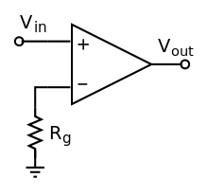](https://en.wikipedia.org/wiki/File:Op-amp_open-loop_1.svg)

## Open loop amplifier

The magnitude of *A*OL is typically very large—100,000 or more for integrated circuit op-amps—and therefore even a quite small difference between *V*+ and *V*− drives the amplifier output nearly to the supply voltage. Situations in which the output voltage is equal to or greater than the supply voltage are referred to as *saturation* of the amplifier. The magnitude of *A*OL is not well controlled by the manufacturing process, and so it is impractical to use an open loop amplifier as a stand-alone [differential amplifier](https://en.wikipedia.org/wiki/Differential_amplifier).

Without [negative feedback](https://en.wikipedia.org/wiki/Negative_feedback_amplifier), and perhaps with [positive feedback](https://en.wikipedia.org/wiki/Positive_feedback) for [regeneration](https://en.wikipedia.org/wiki/Regenerative_circuit), an op-amp acts as a [comparator](https://en.wikipedia.org/wiki/Comparator). If the inverting input is held at ground (0 V) directly or by a resistor Rg, and the input voltage Vin applied to the non-inverting input is positive, the output will be maximum positive; if Vin is negative, the output will be maximum negative. Since there is no feedback from the output to either input, this is an [*open loop*](https://en.wikipedia.org/wiki/Electronic_feedback_loops) circuit acting as a [comparator](https://en.wikipedia.org/wiki/Comparator).

## Closed loop

An op-amp with negative feedback (a non-inverting amplifier)

[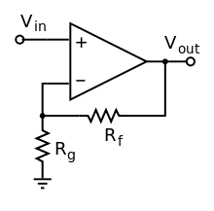](https://en.wikipedia.org/wiki/File:Operational_amplifier_noninverting.svg)If predictable operation is desired, negative feedback is used, by applying a portion of the output voltage to the inverting input. The *closed loop* feedback greatly reduces the gain of the circuit. When negative feedback is used, the circuit's overall gain and response becomes determined mostly by the feedback network, rather than by the op-amp characteristics. If the feedback network is made of components with values small relative to the op amp's input impedance, the value of the op-amp's open loop response *A*OL does not seriously affect the circuit's performance. The response of the op-amp circuit with its input, output, and feedback circuits to an input is characterized mathematically by a [transfer function](https://en.wikipedia.org/wiki/Transfer_function); designing an op-amp circuit to have a desired transfer function is in the realm of [electrical engineering](https://en.wikipedia.org/wiki/Electrical_engineering). The transfer functions are important in most applications of op-amps, such as in [analog computers](https://en.wikipedia.org/wiki/Analog_computers). High input [impedance](https://en.wikipedia.org/wiki/Electrical_impedance) at the input terminals and low output impedance at the output terminal(s) are particularly useful features of an op-amp.

# Objectives:

By the end of the practice, the student will check the basic settings with operational amplifiers ampplificador investor, amplifier not investor, followed by voltage, summing amplifier, amplifier sustractor, amplifier integrator and amplifier derived; as well as interpret the results obtained for the circuits mentioned above.

# Material

* 1 Experimentation tablet operational (protoboard)
* 4 TL071 o LM741 (operational amplifier)
* 2 Resistors of 560Ω a ¼ W
* 6 Resistors of 1KΩ a ¼ W
* 2 Resistors of 2.2KΩ a ¼ W
* 4 Resistors of 10KΩ a ¼ W
* 2 Resistors of 15KΩ a ¼ W
* 5 Resistors of 100KΩ a ¼ W
* 2 Resistors of 150KΩ a ¼ W
* 2 Resistors of 220KΩ a ¼ W
* 2 Resistors of 560KΩ a ¼ W
* 2 Resistors of 4.7KΩ a ¼ W
* 2 Capacitor 0.01µF
* 2 Capacitor 0.0022µF
* 2 Capacitor 100pF

# Equipment

* Dual power supply
* digital multimeter
* function generator
* oscilloscope general purpose
* Coaxial cables with BNC terminal-Caiman
* cables caiman-CAIMAN
* BANANA leads-CAIMAN

# Experimental development

On all circuits are used the operational amplifier TL071 with ±12V Power Supply

## Inverter amplifier

Assemble the circuit as shown in the following figure

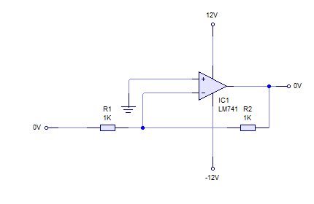

Enter a signal denoidal with 1 Vpp at a frequency of 1kHz in the entrance of the circuit (Vi)

In the oscilloscope observe the magnitude of the voltage peak to peak input on channel 1 and channel 2 output voltage, compare the phase (note the investment of the output signal with respect to the entry) determine the gain and plot the Waveforms obtained

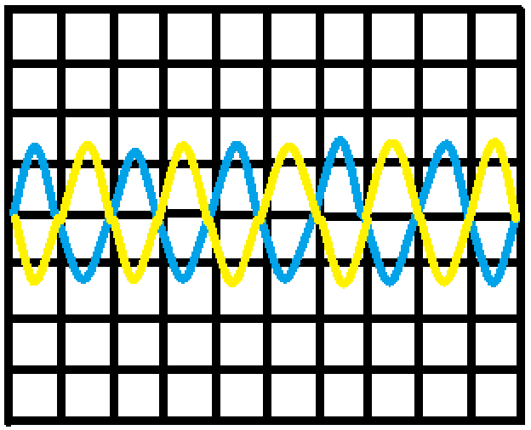

V/div canal **1 500mV**

Mseg/div **5.00V**

V/div canal **2 500µs**

|  |  |  |  |
| --- | --- | --- | --- |
|  | Entrada | Salida | Ganancia |
| Teórico |  |  |  |
| Práctico |  |  |  |

## Noninverting amplifier

Connect according to the following configuration

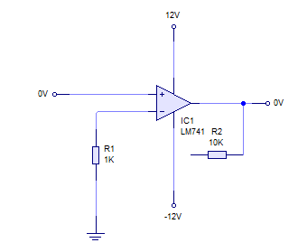

Enter a sine signal with 1 Vpp at a frequency of 1 kHz at the entrance of the circuit (VI). Measure the input voltage in channel 1 and the output voltage in channel 2 and determine the gain of the amplifier. Note that the output signal is in phase with the input signal. Plot the Waveforms obtained

Increase the input signal amplitude until you see the saturation of the output, noting the positive and negative value

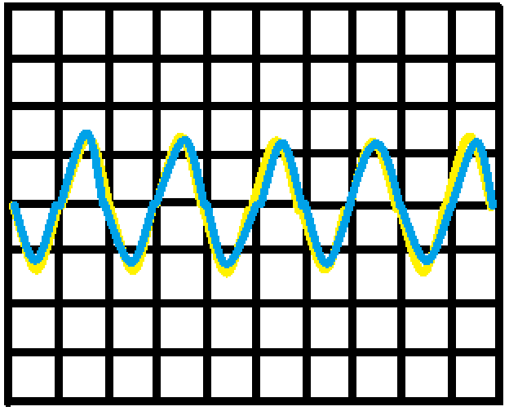

V/div canal 1: **500mV**

V/div canal 2: **5.00V**

Mseg/div: **500µS**

|  |  |  |  |
| --- | --- | --- | --- |
|  | Entrada | Salida | Ganancia |
| Teórico |  |  |  |
| Práctico | 1.12 | 11.4 | 10.17 |

## Voltage Follower

Check its operation through voltage measurements of input and output. Build the following circuit

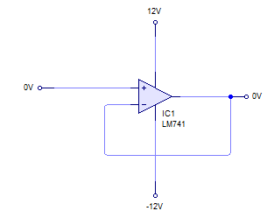

Enter a sine signal with 5Vpp at a frequency of 1 kHz at the entrance of the circuit (VI). In the oscilloscope observe the magnitude of the input voltage in channel 1 and draw the Waveforms obtained

## Summing amplifier

Build the following circuit

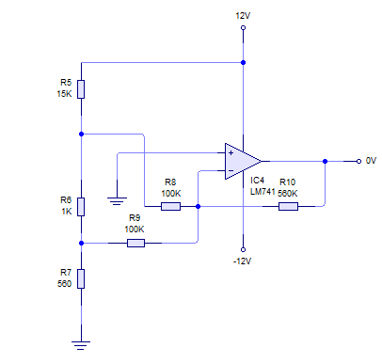

Measure the input voltages (V1 and V2) and the output voltage (Vo) with the help of the voltmeter by filling the following table in the area of the theoretical results. To fill the table in the theoretical area make the calculations to obtain the values

## Sustractor Amplifier

Build the following circuit

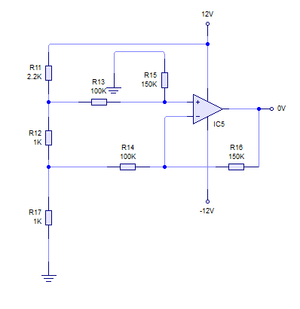

The circuit of the figure measure different input voltages (V1 and V2) and the output voltage (Vo) with the help of the voltmeter by filling the following table in the area of the theoretical results. To fill the table in the theoretical area make the calculations to obtain the values

## Integrator

Build the configuration of an integrator as shown in the following figure and enter in the input voltage a square signal of 1Vpp at 1 khz and measure the signal on channel 1 and channel 2 Place the output signal

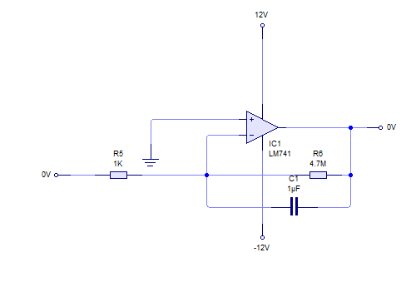

## Derivator

Build the configuration of an integrator as shown in the following figure and enter in the input voltage a square signal of 1Vpp at 1 khz and measure the signal on channel 1 and channel 2 Place the output signal

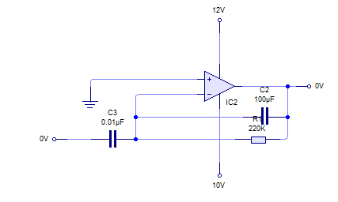

## Theoretical analysis

To fulfil the theoretical analisi of all the previous circuits

## Simulated analysis

To realize the analysis simulated of all the circuits

## Comparison of the theoretical and practical results

To analyze all the values and to give an explanation of the variations or differences that exist in the values obtained so much in terico, simulated and practical

## Questionnaire

1. What does represent the negative sign in the circuits investing, resumptive, derivador and integrator?

**The negative sign of the expression indicates the phase investment between the entry and the exit.**

1. It explains because there exists a difference between the theoretical voltage of exit and I practise of the circuits resumptive and restador

**Because the voltage in the theoretical results they are mathematical whereas actually the voltage that can reach is alone of 12 of entry and of exit the maximum thing**

1. What function has the circuit followed by voltage?

**They try to take advantage of the characteristics of high impedance of entry and fall of exit of the operational amplifiers.**

1. Which is the purpose of adding a resistance in parallel to the capacitor in the integrator and a capacitor in parallel to the resistance of the derivador?

**The resistor simply introduces a DC negative feedback preventing the op-amp from saturation.**

**Is a difference between the two discharging elements - the reset switch removes all the charge inside the capacitor (caused by both the AC and DC signals) while the resistor selectively removes only the undesired DC component. In addition, the DC integrator does not function during the reset. So we should use a reset switch in the case of "occasionally working" DC integrators, and a resistor - in the case of "continuously working" AC integrators.**

# Conclusions

### Konishi Govantes Jorge

### Luciano Espina Melisa

This practice I help myself to understanding better the different functionings of the operational amplifiers on having observed every stage in which there were the channels due connected to each of the points of the different circuits it was possible to identify the zones where they were operating correctly and how it was interacting with the capacitor and the different values of resistances; there were verified the measures to which there was coming the voltage of exit of the amplifier

### Mena Ortiz Erick Jafet